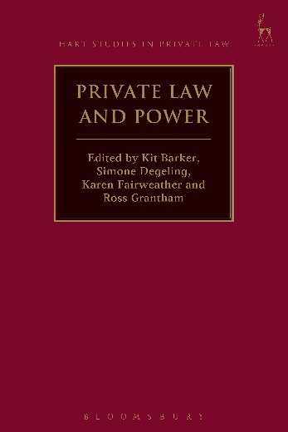**Private Law and Power**

*Edited by Kit Barker, Simone Degeling, Karen Fairweather and Ross Grantham*

The aim of this edited collection of essays is to examine the relationship between private law and power – both the public power of the state and the ‘private’ power of institutions and individuals. It describes and critically assesses the way that private law doctrines, institutions, processes and rules express, moderate, facilitate and control relationships of power. The various chapters of this work examine the dynamics of the relationship between private law and power from a number of different perspectives – historical, theoretical, doctrinal and comparative. They have been commissioned from leading experts in the field of private law, from several different Commonwealth Jurisdictions (Australia, the UK, Canada and New Zealand), each with expertise in the particular sphere of their contribution. They aim to illuminate the past and assist in resolving some contemporary, difficult legal issues relating to the shape, scope and content of private law and its difficult relationship with power.

***Kit Barker*** *is Professor of Private Law,* ***Karen Fairweather*** *is an Associate Lecturer and* ***Ross Grantham*** *is Professor of Commercial Law, all at the TC Beirne School of Law, University of Queensland.*

***Simone Degeling*** *is Professor of Law at UNSW Australia.*

January 2017 | 9781509905997 | 320pp | Hardback | RSP: ~~£75~~

**Discount Price: £60**

**Click** [**here**](http://www.bloomsburyprofessional.com/uk/private-law-and-power-9781509905997/) **to order online and use the discount code CV7 at the checkout to get your 20% off**

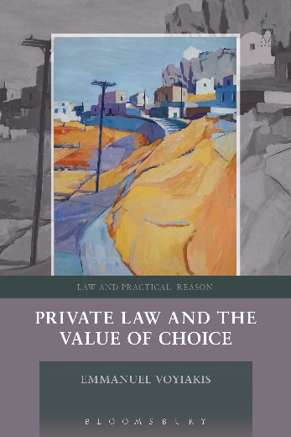**Private Law and the Value of Choice**

*Emmanuel Voyiakis*

Some say that private law ought to correct wrongs or to protect rights. Others say that private law ought to maximise social welfare or to minimise social cost.

In this book, Emmanuel Voyiakis claims that private law ought to make our responsibilities to others depend on the opportunities we have to affect how things will go for us. Drawing on the work of HLA Hart and TM Scanlon, he argues that private law principles that require us to bear certain practical burdens in our relations with others are justified as long as those principles provide us with certain opportunities to choose what will happen to us, and having those opportunities is something we have reason to value.

The book contrasts this ‘value-of-choice’ account with its wrong- and social cost-based rivals, and applies it to familiar problems of contract and tort law, including whether liability should be negligence-based or stricter; whether insurance should matter in the allocation of the burden of repair; how far private law should make allowance for persons of limited capacities; when a contract term counts as ‘unconscionable’ or ‘unfair’; and when tort law should hold a person vicariously liable for another’s mistakes.

***Emmanuel Voyiakis*** *is an associate professor at the LSE Law Department.*

January 2017 | 9781841138862 | 272pp | Hardback | RSP: ~~£65~~

**Discount Price: £52**

**Click** [**here**](http://www.bloomsburyprofessional.com/uk/private-law-and-the-value-of-choice-9781841138862/) **to order online and use the discount code CV7 at the checkout to get your 20% off**

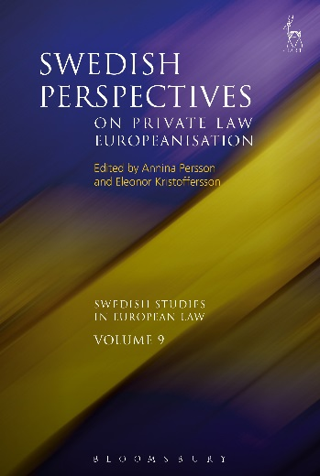**Swedish Perspectives on Private Law Europeanisation**

*Edited by Annina H Persson and Eleonor Kristoffersson*

As part of the European integration, an ambitious programme of harmonisation of European private law is taking place. This new edition in the *Swedish Studies in European Law* series, the work of both legal scholars and politicians, aims to create a modern codification in the tradition of the great continental codifications such as the BGB and the Code Civil. A significant step towards this development was taken in 2009 with the creation of the Draft Common Frame of Reference which contains model rules for a large part of central private law.

The process raises a number of questions. What are the advantages and disadvantages of such an intensive process of harmonisation? Are there lessons to be learnt from the Europeanisation of private law through history? Are there any further steps which have been taken in order to create a European private law? What is the future of European private law? These crucial questions were discussed at a conference in Stockholm, sponsored by the Swedish Network of European Legal Studies. This important volume includes the answers offered by leading scholars in the field.

***Annina H Persson*** *is Professor in Private Law and Eleonor Kristoffersson is Professor in Tax Law, both at Örebro University, Sweden.*

January 2017 | 9781849466974 | 216pp | Hardback | RSP: ~~£55~~

**Discount Price: £44**

**Click** [**here**](http://www.bloomsburyprofessional.com/uk/swedish-perspectives-on-private-law-europeanisation-9781849466974/) **to order online and use the discount code CV7 at the checkout to get your 20% off**